- INTRODUCTION

Transformer fault diagnosis based on massive vibration data
Han Bo Deng¹,Jie Hu¹,Xu Sheng Wang¹,Miao Yu¹
1. Key Lab for Optoelectronic Technology and Systems, Ministry of Education, College of Optoelectronic Engineering, Chongqing University, Chongqing 400044, China

Abstract: Transformer is one of the key equipment in the power industry and its safe operation is very important to ensure the reliability of power network. Therefore, transformer fault diagnosis has important engineering value and scientific significance. The fault diagnosis method based on transformer vibration characteristics has the advantages of strong anti-interference and good stability. In order to determine fault types based on the vibration signal on the surface of the transformer tank, this paper combines K-means clustering and BP neural network, and adopts distributed computing framework to train the model by massive data stored in distributed storage system. The results revealed that the model trained by this method can effectively diagnosis transformer faults.
Key Words: Fault Diagnosis, Distributed Storage, Distributed Computing

Transformers are important equipment in power systems, and their operating conditions directly affect the safety of the system. At present, the main methods of transformer detection and fault diagnosis are oil chromatography detection method, vibration detection method, acoustic wave detection method, partial discharge detection method, etc^{[1-7]}. Thereinto, as an effective supplement for transformer monitoring technology, the vibration detection method develops rapidly^{[8-9]}, which is diagnosed by analyzing the vibration signal of the transformer tank. Compared with the traditional methods, the vibration method has no electrical connection to the entire power system, has no influence on the normal operation of the entire power system, therefore, it has strong anti-interference ability and sensitivity, and thus can monitor the state of power transformer safely and reliably. Besides, the vibration data extracted from the transformer surface is simple and applicable to all types of transformers, which is conducive to improving the portability of the diagnosis system. That is, one detection system can diagnose different types of transformers, and which has a good guiding significance for the fault diagnosis research of transformers.
The vibration of transformer body mainly comes from four aspects: First of all, vibration caused by the electric power between the turns of the winding, which is generated by the load current in the winding; Second, the periodic vibration of iron core caused by magnetostriction of silicon steel sheet. Third, the tank wall vibration due to the magnetic leakage between silicon steel seam and lamination; Fourth, the iron core vibration caused by electromagnetic attraction due to magnetic leakage. Among these vibration sources, the magnetostriction of the iron core and the vibration caused by the electric power of the turns of winding are the main sources of vibration^{[10]}.
Currently, a lot of research has been conducted on transformer fault diagnosis based on vibration method and combined machine learning algorithm, and certain success has been achieved^{[11-15]} . However, most of them just use small-scale data to do diagnostic model training on a single computer. Although the model trained in this way may have a good performance on the test set, but it may fail on the verification set. That is because machine learning algorithm relies on data sampling, in practice the samples are often difficult to do random, so the trained model is not very accurate. In order to improve the accuracy and generalization of the diagnostic model, we could use massive data to train the model. However, as the hard disk capacity and computing capacity of the single computer is limited, while improving the hardware performance is often accompanied by high cost, it is difficult to realize the model training with a large number of train sets by the single computer.
In recent years, Hadoop and Spark have been widely used, so it is possible for training massive data. Hadoop, which is a distributed system, includes HDFS and MapReduce. HDFS is composed of so huge data nodes that HDFS can store massive data. MapReduce possess strong computing power, it enables these data nodes to do parallel computing. Nevertheless, MapReduce is time-consuming when used to implement distributed machine learning algorithms. That’s

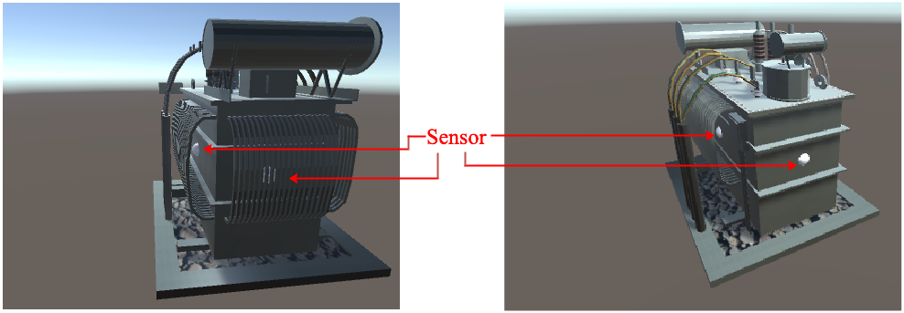
Fig 1. Schematic diagram of acceleration sensor distribution

because the parameter learning of machine learning algorithm is usually an iterative process. Namely, the results of each calculation should be used as input of the next iteration. If making use of MapReduce in this process, intermediate results only can be stored on disk first then read it from disk again at the next time of calculation. For iterations that occur frequently, this consumes disk IO considerably as well as time. In order to train model with huge data, it is necessary to process massive data and perform a large number of iterations. This requires strong processing capacity provided by machine learning platform. Thus, an efficient and fast calculation method is particularly important. Fortunately, Spark is a distributed computing framework developed by Apache. It stores the intermediate results of iterative computing in memory rather than disk, which makes it very suitable for iterative computing. So it can quickly batch large amounts of data^{[16]}.
In paper[20], Qi Jian Peng et of Chongqing University utilized dissolved gas analysis (DGA) to diagnose transformer fault and preliminarily selected train set by K-means clustering, then trained model through supervised learning method. Transformer failure diagnosis model obtained in this way is more accurate than the model trained only by supervised learning method. In paper[19], Jia Rong et of Xi’an University of Technology extracted the characteristics of vibration data via wavelet packet decomposition then trained by neural network, and the obtained trained model had a high accuracy in failure recognition. In this paper, combine the advantages of the above two papers, the model of transformer failure diagnosis based on K-means clustering and BP neural network is adopted, and Spark's machine learning package ML, a distributed framework, is used to implement the model. Process is as follows: Data preprocessing is first performed in order to remove noise. Then, signal energy entropy value of each frequency band extracted by wavelet packet decomposition. Then, these energy entropy values are used as features to train model. Through this scheme, the problem of low generalization and accuracy of the model due to the small number of train sets can be improved, thus achieving better transformer failure prediction.
- DATA COLLECTION AND FEATURE EXTRACTION
  - Data Collection
The vibration measurement object in this paper is a transformer with rated capacity of 500kV·A, rated winding voltage of 10.5/0.4kv and wiring group of Dyn11. The acceleration sensor was firmly absorbed on the transformer by permanent magnet, and the surface of the permanent magnet was coated with an insulating paint, which ensured the "floating ground" of the sensor shell and had a good ability to resist electromagnetic interference.
As for the choice of vibration measuring points of transformer, according to the transmission path and direction of transformer vibration, researchers mainly arrange the measuring points in the front middle or top surface of the oil tank, where the radial vibration transmission path of the transformer is the shortest while the amplitude is the highest. Then, the feature vector is determined by the vibration data, and the corresponding fault diagnosis model is also constructed. However, according to the safety operating rules in the actual operating conditions of transformers, the acceleration sensor is not allowed to be attached on the top surface of the transformer tank. In addition, since the left and right side surfaces of the transformer tank are equipped with heat sink, it is impossible to install the acceleration sensor on the front middle of the fuel tank surface. Therefore, based on the actual conditions of the transformer site, this paper employed four sensors installed on the front, back, left and right sides of transformer, respectively. The adsorption position is as shown in Fig 1.
In order to get the specific vibration features, flowchart and physical drawing of the test system are shown in Fig 2. and Fig 3.
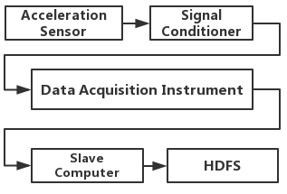
Fig 2. Flowchart of the test system

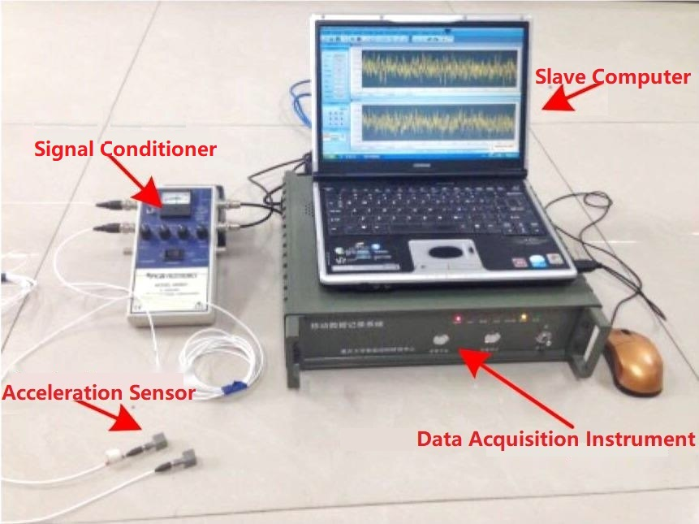
Fig 3. Physical drawing of the test system

The signal sampling frequency of the acceleration sensor is set as 2048Hz. The signal conditioner is responsible for the vibration signal conversion; The data acquisition instrument collects the signal of acceleration sensor and transmits it to slave computer; In order to avoid the influence of external disturbance on fault diagnosis, all the connections between the acceleration sensor and slave computer are connected by shielded cable; The collected vibration data is preprocessed by slave computer and then sent to HDFS of Hadoop for storage through 4G network. The data volume on HDFS in this paper is about 1T, 70% of which is used as the train set, the remaining 20% and 10% as the test set and validation set, respectively.
  - Data Preprocessing
The vibration data collected by the sensor is mixed with the direct current (DC) component, so data cleaning is required first. Fig 4. shows the FFT amplitude-frequency diagram of the original vibration data.
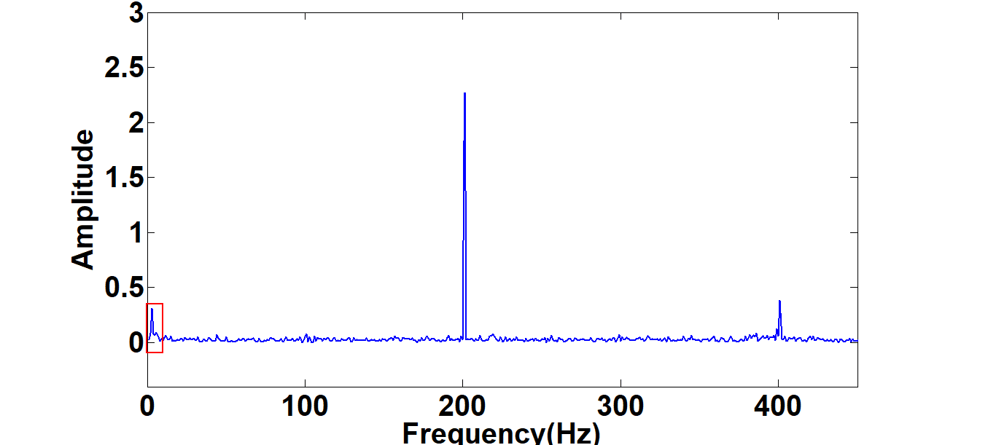
Fig 4. FFT of the pre-filtered vibration signal

According to the prior knowledge, the DC component is concentrated in the portion below 5Hz, so this part can be removed by a high-pass filter. FIR high-pass filter is adopted in this paper, and its normalized cut-off frequency can be calculated by:
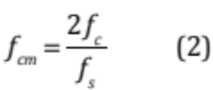
Where f_{s} represents actual sampling frequency, is equal 2048Hz; f_{c} represents the actual cut-off frequency, is equal 5Hz. The filtered data is as shown in Fig 5. It can be seen from the figure that the DC component has been filtered out.
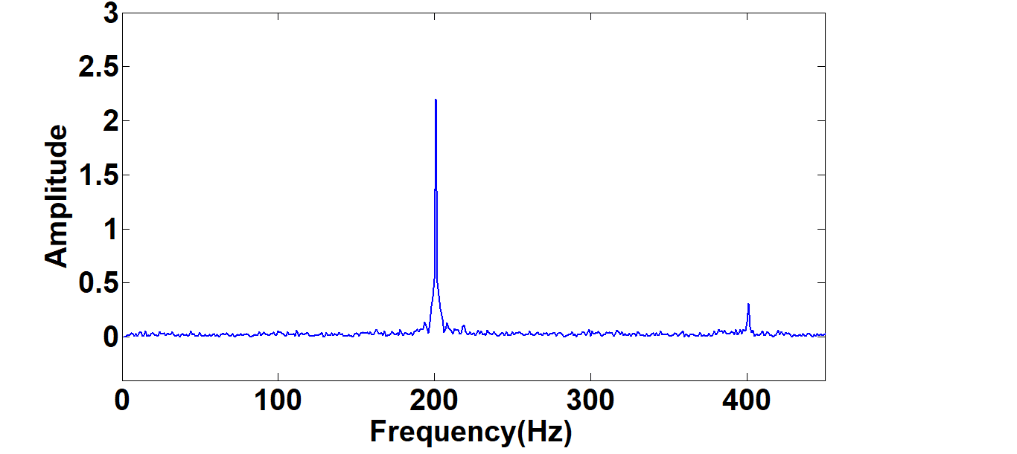
Fig 5. FFT of the filtered vibration signal
  - Feature Extraction
When transformer faults occur, the vibration characteristics of the transformer body will be significantly changed, which manifests as the different attenuation or enhancement phenomenon of the vibration signals at different frequency bands^{[17]}. This attenuation or enhancement phenomenon will company with the change of energy, so this paper will extract the vibration energy of transformer as the feature for the next modeling work. Significantly, as the wavelet packet decomposition can obtain detailed information at different frequency bands, this paper uses wavelet packet decomposition to extract the energy entropy values at different frequency bands as the feature of transformer vibration.
As shown in Fig 6, the vibration data with 2048 points per second are cleaned first and then performed by three-layer wavelet packet decomposition. It can be seen that the data points of 1-second are decomposed into 8 frequency bands after wavelet packet decomposition.
Then the signal energy entropy values under these 8 frequency bands are solved, and the energy entropy values are used as the feature vectors for diagnosis. The calculation method is as follows:
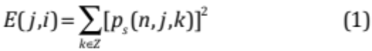
Where E(j,i) represents the energy entropy value of the i-th
node on the decomposition level j; p_{s}(n,j,k) is the n-layer wavelet packet transform coefficient. The energy entropy percentage of each node under different conditions is as shown in Fig 7. Fig 8. and Fig 9. Respectively.
After performing the above operations on other vibration data, the energy entropy percentage of each node are shown in Table1. (because of the limited space, this paper only selects part of the data for display).

Table1. The energy entropy percentage of each node under different status
H1(%) | H2(%) | H3(%) | H4(%) | H5(%) | H6(%) | H7(%) | H8(%) | Status
4.24 | 84.26 | 2.32 | 8.01 | 0.01 | 0.01 | 1.12 | 0.03 | normal
4.15 | 82.45 | 3.75 | 8.41 | 0.04 | 0.03 | 1.14 | 0.03 | normal
1.95 | 70.32 | 5.54 | 9.50 | 1.05 | 1.03 | 5.29 | 4.05 | core fault
1.89 | 68.57 | 4.98 | 10.22 | 1.87 | 1.24 | 6.23 | 5.00 | core fault
2.04 | 70.04 | 17.79 | 9.61 | 0.14 | 0.16 | 0.13 | 0.09 | winding fault
3.12 | 65.03 | 22.04 | 9.22 | 0.15 | 0.16 | 0.16 | 0.12 | winding fault

As can be seen from the test data in Table1, the proportion of wavelet packet energy H2 significantly decreases and that of H7 and H8 significantly increases when transformer core fault occurs. Meanwhile, the proportion of wavelet packet energy H2 significantly decreases and that of H3 significantly increases when transformer winding fault occurs. This is because that when transformer faults occur, the vibration generated by the fault core or winding increases, which destroy the energy distribution of all frequency bands under the normal state of transformer.
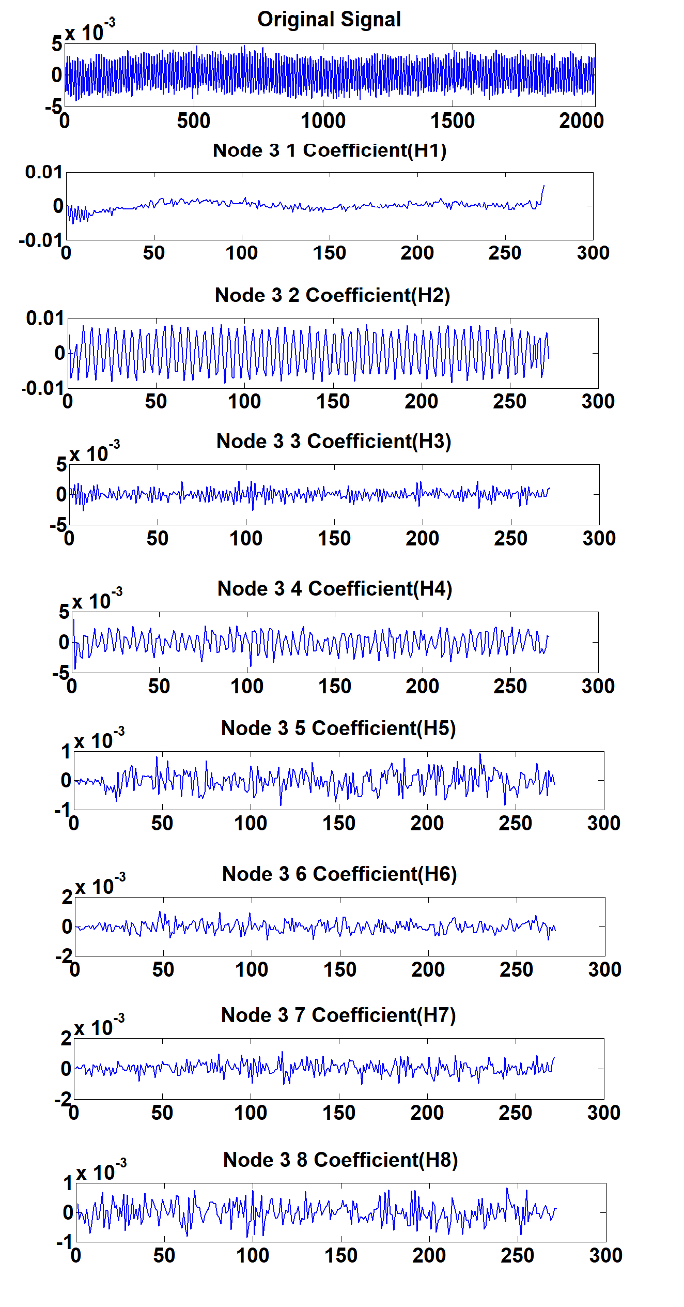
Fig 6. The result of a three-layer wavelet packet decomposition of a 1 second vibration data

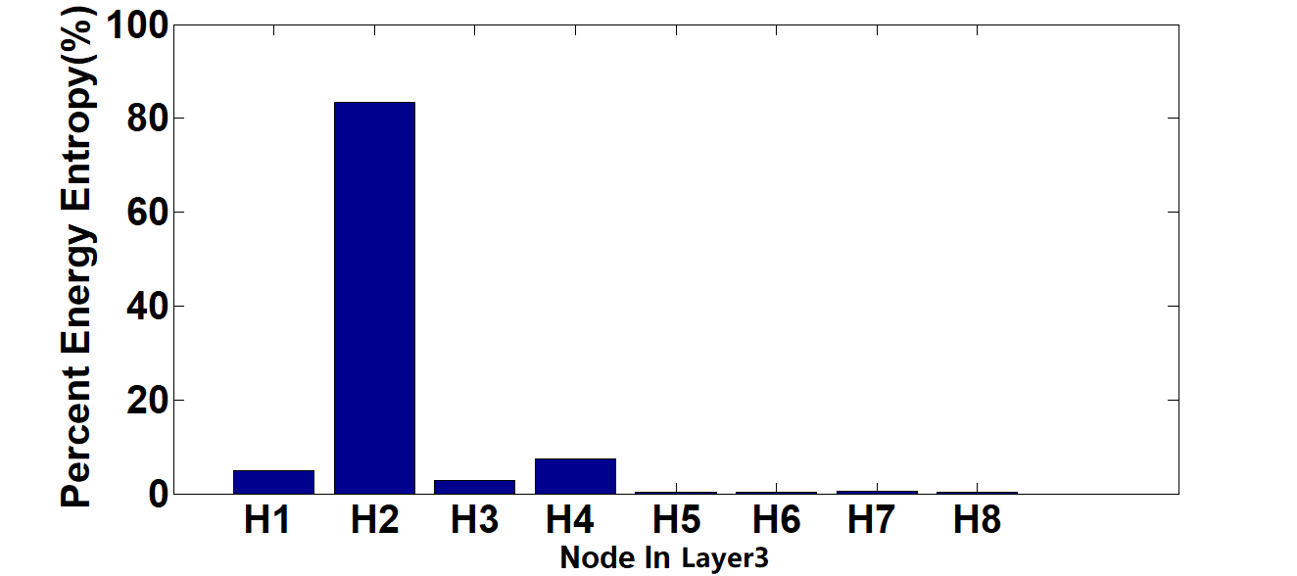
Fig 7. The energy entropy percentage of each node under normal conditions

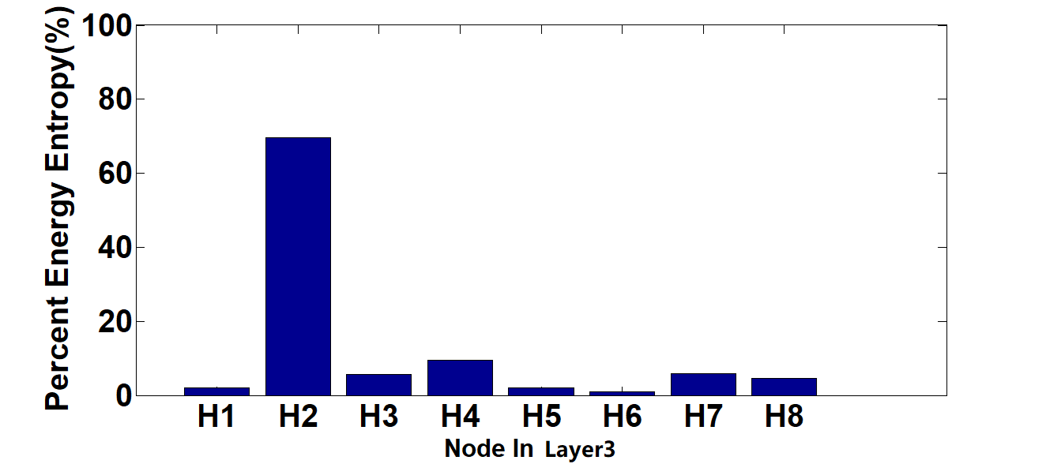
Fig 8. The energy entropy percentage of each node under core fault

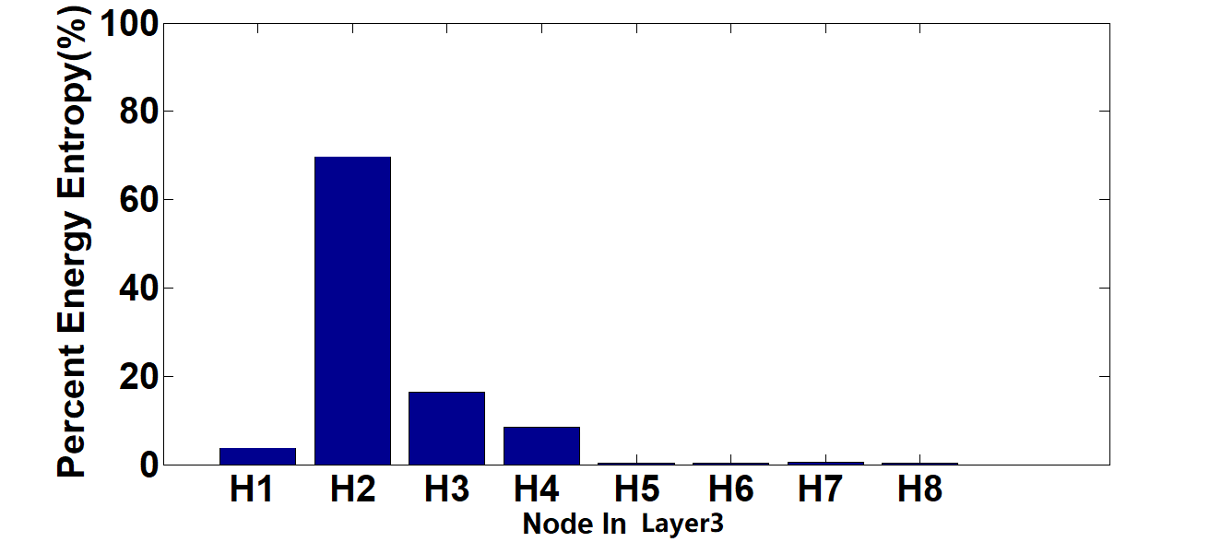
Fig 9. The energy entropy percentage of each node under winding fault

These results are consistent with the theoretical analysis results in paper[18] and paper[19]. According to the different situations of fault occurrence, the energy entropy value of wavelet packet changes correspondingly. Therefore, it can be used as the feature vector to judge whether the transformer has faults.

  - Train Set Construction
In order to obtain better training effects, the feature vector should be normalized first before training and then the method of K-means clustering is adopted for simple data classification.
K-means clustering is a common clustering algorithm, which is primarily used to assemble data points according to the predetermined number of clusters. The fundamental of K-means algorithm is clustering with a focus on k (referring to an amount) points in the space, and classifying the objects closest to them. Then by means of iteration, the value of each cluster center is successively updated until the best K-means clustering result is achieved.
In the selection of initial clustering points, the K-means algorithm of Spark ML references the method of K-means++. That is, It follows a basic principle—the distance between the initial cluster centers should be as far as possible. Following are the basic steps:
- Pick out a point randomly from the data set X as the first initial point.
- Calculate the distance D(x) between all points in the data set and the newly selected center point.
- Select the next center point to make
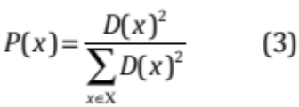
has a maximize value.
- Repeat the steps (2) and (3) until K initial points are selected.
In this paper, the transformer operating conditions can be divided into four categories. The first is normal operation, and the rest are fault operations, respectively are only winding fault, only core fault, and both core and winding faults. So K equals 4. After K-means clustering is performed for feature data, about 32.34% of the samples are classified incorrectly. Afterwards, the correctly classified data are used to train BP neural network. K-means clustering does better in distinguishing, extracting and amplifying useful features and thus can train a more accurate BP neural network model^{[20]}.
- MODEL TRAINING AND FAULT DIAGNOSIS
3.1 Model Training
The BP neural network carries multilayered nodes, and nodes of each layer are wholly connected to those of the next layer in the network. The structure is as Fig 10.
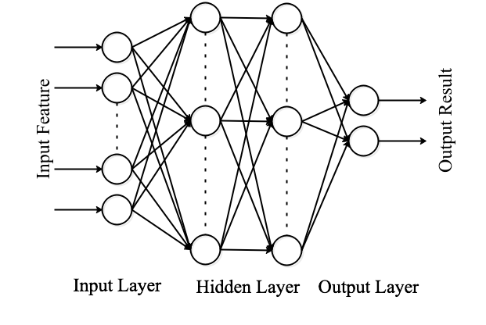
Fig 10. Structure of BP neural network

The nodes of the input layer represent the input data, the output data is obtained by linearly combining the input data with the Weight w and Bias b of the nodes on the hidden layer and acting out an activation function.
The BP neural network learns the model by back propagation. And in this paper the logical loss function and L-BFGS are utilized. The sigmoid equation used by the hidden-layer nodes is:
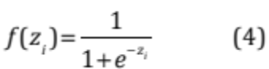
And the softmax equation followed by the output layer is:
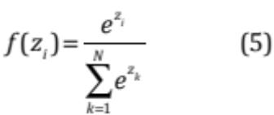
Then those correct sample data of K-means clustering are put into the BP neural network for training, after parameter adjustment, the input layer is set as 8 nodes, the first hidden layer is 60 and the second hidden layer is 30, with 2 nodes output in the end. The 2 output nodes represent the state of winding and core respectively, and output value is greater than 0.6 indicating the abnormal state. When the number of iterations reaches 1489, a higher precision rate and generalization can be obtained. The precision rate is 93.65% in test set. Fig 11 shows the convergence curve:
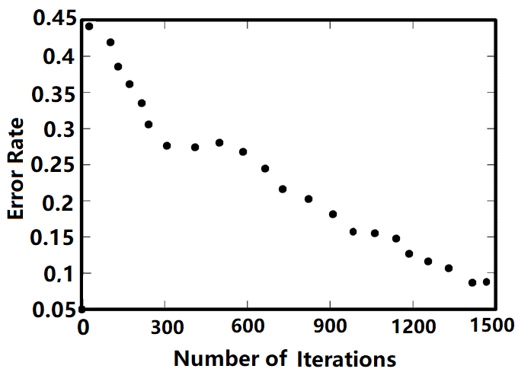
Fig 11. Convergence curve
3.2 Fault Diagnosis
Table 2 shows the accuracy of the model on the test set and verification set respectively. It can be seen from the table that there are 93.65% of data are correctly diagnosis in test set and 91.45% of data are correctly diagnosis in verification set. The accuracy in verification set is only 2.2% lower than that on test set. So the method proposed in this paper can be effectively used for transformer fault diagnosis. And it has high generalization and accuracy.

Table 2. Diagnosis results on test and validation set
Actual  Diagnosis |  | Both core and winding are normal |  |  |  | Both core and winding are abnormal |  |  |  | Only core is normal |  |  |  | Only winding is normal
 |  | Test set |  | Verification set |  | Test set |  | Verification set |  | Test set |  | Verification set |  | Test set |  | Verification set
Both core and winding are normal | 0.932 |  | 0.890 |  | 0.011 |  | 0.021 |  | 0.022 |  | 0.036 |  | 0.025 |  | 0.003
Both core and winding are abnormal | 0.021 |  | 0.032 |  | 0.941 |  | 0.922 |  | 0.038 |  | 0.052 |  | 0 |  | 0.004
Only core is normal | 0.014 |  | 0.026 |  | 0.040 |  | 0.017 |  | 0.922 |  | 0.90 |  | 0.024 |  | 0.047
Only winding is normal | 0.033 |  | 0.052 |  | 0.008 |  | 0.04 |  | 0.008 |  | 0.012 |  | 0.951 |  | 0.946

- CONCLUSION
In this paper, K-means clustering and the BP neural network are used for model training. First, the data are denoised; Next, the energy entropy is extracted as the feature vector; Then, the train set is screened by K-means clustering and the screened set is trained by the BP neural network; Finally, the trained BP neural network is employed as the transformer fault diagnosis model. The accuracy rate of fault diagnosis reaches 91.45% in verification set. Compared with model training based upon limited data on a single computer, the computing framework used in distributed storage and distributed computing system boasts better generalization and accuracy. According to the result analysis, the method proposed in this paper can contribute to a more accurate monitoring in transformer fault, help maintenance personnel make timely repairs on the transformers and ultimately ensure proper running of the power system.
References
- Guo Jian Long, Lan Xiao Meng. A new method of monitoring and diagnosis is for operation condition of transformer [J]. Transformer, 48(1):40-43, 2010.
- Zhao Shi Qin, Zhou Jian. Multi-point grounding failure diagnosis and treatment for the transformer Iron core[J]. Guizhou Electric Power Technology, 18(12):47-49, 2015.
- Yao Chen Guo, Zhao Zhong Yong, Li Cheng Xiang. Online detecting winding deformation power transformer based transient over voltage[J]. High Voltage Engineering, 41(3): 873-880, 2015.
- Ma Hong Zhong, Geng Zhi Hui, Chen Kai, et al. A new fault diagnosis method for power transformer winding deformation based on vibration[J]. Auto mation of Electric Power systems, 37(8):89-95, 2013.
- Guo Chuang Xin, Zhu Cheng Zhi, Zhang Lin, et al. A fault diagnosis method for power transformer based on multiclass multiple-kernel learning support vector machine[J]. Proceeding of the CSEE, 30(13):128-134, 2010.
- Pan Liang Liang, Zhao Shu Tao, Li Bao Shu. Electrical equipment fault diagnosis based acoustic wave signal analysis[J]. Electric Power Automation Equipment, 29(8):87-90, 2009.
- BagheriM, NaderiMS, BlackburnT. Advanced transformer winding deformation diagnosis:moving from off-linetoon-line[J]. IEEE Transactions on Dielectrics and Electrical Insulation, 19(6):1860-1870, 2012.
- Wu Shu You. Research on state monitoring and fault diagnosis of power transformer based on vibration signal analysis method [D]. University of science and technology of China. DOI:10.7666/d.y1706412, 2009 .
- Xie Po An, Jin Zhi Xi, Rao Zhu Shi, et al. Vibration detection of the pinch state of no-load transformer windings[J]. High Voltage Engineering, 33(3):188-189, 2007.
- Wang Wei, Wang Nan, Wei Ju Fang et al. Fault detection of transformer vibration method based on wavelet packet analysis and distance criterion criterion[J]. Transformer, 55(2): 58-62, 2018.
- Wang Chun Ning, Zhu Yue Guang, Ma Hong Zhong et al. Transformer fault diagnosis based on vibration signal and wavelet neural network[J]. China Electric Power, 2014(4): 75-79.
- Su Shi Zhen, Guo Sheng, Gao Wei et al. Analysis of Transformer Vibration Signal Based on Convolutional Neural Network[J]. Guangdong Electric Power, 31(6): 127-132, 2018.
- Yang Jian, Zhu Yong Li, Wu Zhong Li, et al. Transformer fault diagnosis based on rough set theory and support vector machine [C]. Proceedings of the 25th annual conference of power system and automation major of Chinese universities. North China electric power university,2009:1-4..
- Zhu Wei, Zhang Guang Ming. Application of multi-class classification based on support vector machine in transformer fault diagnosis[J]. Journal of Computer Applications, 30(A01):97-98, 2010.
- Chen Hui, Wu Jie, Zhang Bao Shu, et al. Transformer fault diagnosis method based on bayesian decision tree [C]. Proceedings of the 25th annual conference of Chinese universities on power system and automation. Yanshan university, 2009:1-4.
- Zhang Kuo, S.Alqahtani, M.Demirbas. A Comparison of Distributed Machine Learning Platforms. International Conference on Computer Communication & Networks IEEE, 2017.
- Zhai Sheng Chang, Wang Shi Shan, Li Qing Quan et al. Monitoring Transformer Winding Condition by Vibration Signal Analysis Method[J]. High Voltage Engineering, 28(4):12-13, 2002.
- Ji Sheng Chang, Liu Wei Guo, Shan Ping, et al. Application of wavelet packet analysis in vibration monitoring of transformer core and windings[J]. Chinese journal of electrical engineering, 21(12):24-27, 2001.
- Jia Rong, Li Hong Bin, Kang Hue Xi, et al. Application of improved particle swarm optimization neural network in transformer fault diagnosis[J]. High voltage electrical appliances, 46(5):14-17, 201s.
- Qi Jian Peng, et al. Research on New Technology of Transformer Fault Diagnosis Based on Mean Kernel Clustering and Binary Tree Support Vector Machine. Chongqing Electric Engineering Society Academic Conference 2010:448-451.

 This research was funded by the Chongqing Artificial Intelligence Technology Innovation Major Topic Special Key R&D Project(Grant No.cstc2017rgzn-zdyfX0011).

